POTENTIAL PAID SPEAKERS

Here are a few that I liked. I only liked Jay of the 20 or 30 I watched on Management and Growth. The rest of my emails is presenting Sanborn’s suggestions again. I also added the Ryan Estes a guy that I believe would keep everyone’s attention as a speaker to lead off the conference.

Ryan Estes: https://ryanestis.com/topics/keynote-speaking/passion-on-purpose/; https://ryanestis.com/topics/keynote-speaking/unleash-your-inner-superhero/ https://www.youtube.com/watch?v=cdJ5xCeg6Cg : https://ryanestis.com/topics/keynote-speaking/next-level-leadership/

Jay Acunzo: https://nationalspeakers.com/jay_acunzo I liked the second video.

Mark Scharenbroich (www.nicebike.com)
Connie Podesta (www.conniepodesta.com)
Andrew Davis https://www.youtube.com/watch?v=6PcajF31sJo
Jesse Cole https://www.youtube.com/watch?v=_hVVdXTYQ4s
Ross Shafer https://www.youtube.com/watch?v=Dp9XTybPKzg
Cam Marsten: https://www.youtube.com/watch?v=4bJPy1B6T1w

Lots of great speakers out there! Here are a few I thought would be great for communication and time management:)

LAURA STACK
https://www.youtube.com/watch?v=kv91pSIBq_A
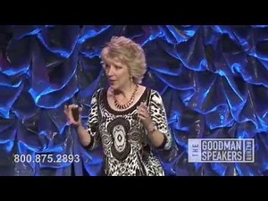 | Laura Stack - Time Management  www.youtube.com  See Laura in action with this preview video from her time management, productivity training and keynote presentations. To find out more about and to book Laura Stack, please visit: http://goodmanspeakersbureau.com/keyn...
CHRISTINE CASHEN
https://www.youtube.com/watch?v=Km7dIkkwOOc
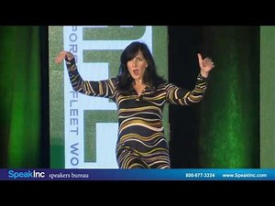 | Keynote Speaker: Christine Cashen • Presented by SpeakInc • AFLA 2016  www.youtube.com  America's Top Humorista. "Use humor to make the ordinary extraordinary!" Fasten your seatbelt and enjoy the ride! Christine Cashen delivers a fast- paced, hilarious program with useful content that makes her a sought after speaker worldwide. For more than 15 years, she has jazzed an amazing variety of audiences throughout the United States ...
BRUCE TULGAN
https://www.youtube.com/watch?v=y0z8qotX_10
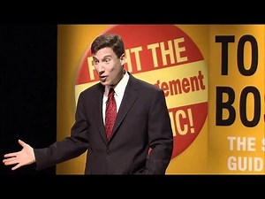 | Bruce Tulgan: Intergenerational Workplace Leadership & Management Expert, Keynote Speaker  www.youtube.com  Bruce Tulgan is internationally recognized as the leading expert on young people in the workplace and one of the leading experts on leadership and management. Bruce is also a best-selling author, an adviser to business leaders all over the world, and a sought-after keynote speaker and management trainer. Since 1995, Bruce has worked with tens ...
MICHAEL BERNOFF
https://www.youtube.com/watch?v=SImoWU5VqhY
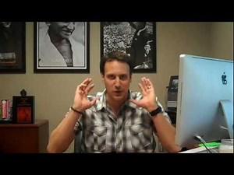 | Turn Procrastination Into Productivity with Michael Bernoff  www.youtube.com  Like what you just saw? Click here for 4 step video on how to make more sales !http://www.persuasionenhancement.com/yt/ Connect With Michael: Facebook: https://www.facebook.com/MichaelBerno... Twitter: http://twitter.com/michaelbernoff Google+ https://plus.google.com/1125708394015... LinkedIn: http:www.linkedin.com/in/michaelbernoff Michael's ...

Customer Loyalty, Digital Mapping, Big Data
Ross Shafer – $15,000 to 22,500 - one of my favorites, recommended to me by Mark Sanborn, last year’s headliner - https://www.espeakers.com/marketplace/profile/3463?btsc=1

Social Media
Neal Schaffer - $7,500 - $10,000 https://www.espeakers.com/marketplace/profile/24105?btsc=1 & https://www.youtube.com/watch?v=vSzJa7_hwno – seems very knowledgeable on cutting edge social media strategies, big data, geotargeting

David Steel - $5000 - $15,000 - https://www.espeakers.com/marketplace/profile/11804?btsc=1 and http://www.thesteelmethod.com

Mike Moran - $5000 - $15,000 - Agile Marketing https://www.espeakers.com/marketplace/profile/19704?btsc=1 & https://mikemoran.com/speaking/training

Negotiation

Very good – keynote - Martin Latz - $15,000 - $20,000 – Create Leverage, Maximizing Leverage & the Strategic Process of Negotiation - https://www.espeakers.com/marketplace/profile/34175?btsc=1

Mark Grossman - $10,000 - $15,000 - https://www.espeakers.com/marketplace/profile/29471?btsc=1
Branding

Maria Ross (maybe above budget, but her lower range fits our target and she lives in CA)
https://www.espeakers.com/marketplace/profile/17213?btsc=1&opentovideo=129529
https://m.youtube.com/watch?v=7TA9HzQ862c

Julie Cottineau
https://www.espeakers.com/marketplace/profile/22494?btsc=1&opentovideo=158253
https://www.espeakers.com/marketplace/profile/22494?btsc=1&opentovideo=158272

Bruce Turkel
https://www.espeakers.com/marketplace/profile/12265?btsc=1&opentovideo=89286
https://www.espeakers.com/marketplace/profile/12265?btsc=1&opentovideo=100213

Michael Solomon
https://www.espeakers.com/marketplace/profile/28545?btsc=1
https://m.youtube.com/watch?v=IuKGpIdXXEk

Humor

Carolyn Carver
https://www.espeakers.com/s/nsas/profile/27362?btsc=1&opentovideo=129598
https://www.espeakers.com/s/nsas/profile/27362?btsc=1

Tim Gabrielson
https://www.espeakers.com/marketplace/profile/10506?opentovideo=98870
https://www.espeakers.com/marketplace/profile/10506?opentovideo=98871

Mark Mayfield
https://www.espeakers.com/s/nsas/profile/1495?opentovideo=145337
https://www.espeakers.com/s/nsas/profile/1495?

Dr. Ivan Joseph
- https://youtu.be/as6pyWMi-eI
- https://youtu.be/Yxrs5EFAt6k

Eric Boles
- https://youtu.be/l4oMPsAUOHw
- https://youtu.be/UVKjBixzwhg

John O’Leary
- https://youtu.be/KGaOZZUDChc
- https://youtu.be/mX-A_wPrwiw

Rrich Horworth
- https://youtu.be/dqOYwuA3pGw
- https://youtu.be/BmvQ-2oa4e4

